Institute for Experimental Surgery and Central Animal Care Facility

Prof. Dr. med. Brigitte Vollmar
Director
brigitte.vollmar@med.uni-rostock.de
Telefon: +49 381 494-2500

kerstin.abshagen@uni-rostock.de
phone: +49 381 494-2503
fax: +49 381 494-2502

Schillingallee 69a
18057 Rostock

www.iec-rostock.de


To the
Editor-in-Chief

BMC Systems Biology

Submission of the manuscript entitled
“Pathobiochemical signatures of cholestatic liver disease in bile duct ligated mice” by Abshagen et al.

Dear Dr. Sands,

please find enclosed the above mentioned research article which we would like to submit for consideration for publication in BMC Systems Biology.

Blocked bile flow from the liver causes immediate damage to liver cells. Repair mechanisms coincide with further damage and make up a complex disease process. Understanding this process will help in the therapy of cholestasis, e.g. caused by gall stones. Furthermore, at specific disease progression stages, the process is similar to other liver diseases: alcoholic liver cirrhosis, fatty liver, and viral hepatitis, thus, it serves as a model for any liver disease. To study the disease process, we blocked the bile duct of mice, and analyzed the liver at 8 different time points up to 14 days thereafter, comprising different stages of the disease. The liver tissue was microscopically evaluated with different staining and the expression of liver-related genes and serum factors were measured. We identified specific phases of the disease process and found genes expressed only at specific time points. The expression of specific genes is highly correlated to certain histological parameters. We set up a computational prediction model for the time after the operation. The results of our work are the basis to discover the relevant molecular interactions and suggest novel markers of the disease process that can be used for diagnosis and therapy.

We feel that this issue might be appealing and attractive for the distinct readership of BMC Systems Biology. The first author warrants that the article is original, has been approved by all authors, is not under consideration by another journal, and has not been published or accepted for publication, either in whole or in part previously. The authors declare that they have no conflicts of interest.

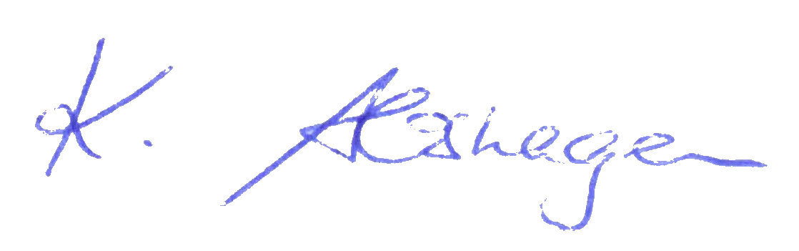
Looking forward to hearing from you,

Most sincerely

Kerstin Abshagen, PhD

